Test Plan for Quote Status Channel changes

This is to test changes to use Transient Quote Status channel instead GMD Quote Status channel.
Test Case1:

- Change the Quote Trigger Time Trading property to 30000 using SA GUI.
- Make sure class AuctionEnabledTradingProperty for NEW HAL is OFF.
- Login two Market Maker MM1 and MM2 to Trade GUI.
- MM1 enters buy customer order for 1.00 X 100
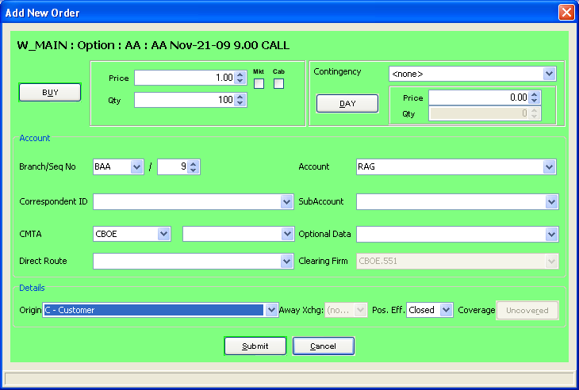
- MM2 enters quote for 0.90 X 100 – 1.00 X 100
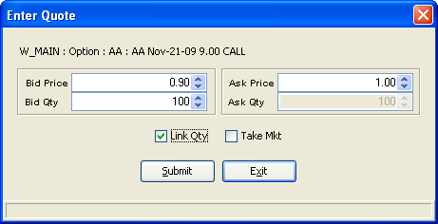

- Logout MM2 and wait until MM1 gets the Fill Report for the buy order.
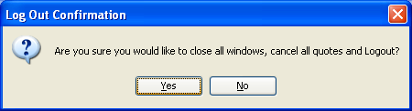

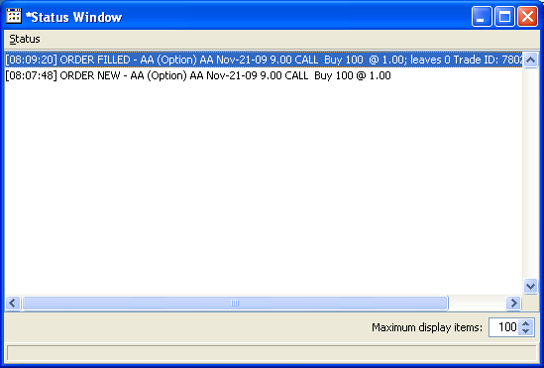

- Login the MM2 user and check the Status window to see the POSS RESEND for the quote Fill Report.

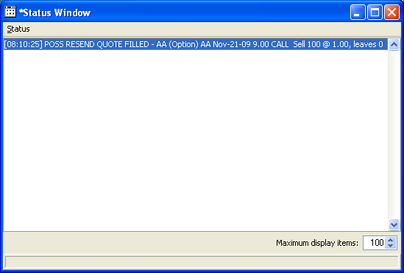

Terst Case2:

- Please setup the MMTN Firm Properties.
- Login to PAR Workstation
- Direct route an Order to PAR from Trader GUI.
- Do Not open the “Floor Trades” Window.
- Trade the Order in PAR with Market Maker this will generate the MMTN
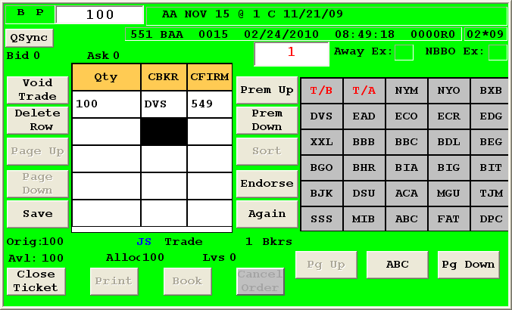

- Logout the Market Maker MM1.
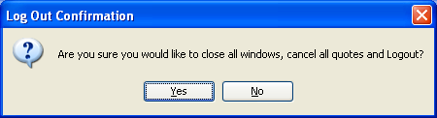

- Login the MM1 and open the Floor Trade Window, will see the POSS RESEND for the MMTN.

